EJB (Egypt) Business Delegation to Balkan
From 21/11/2013 to 28/11/2013
S/N | COMPANY | CONTACT DETAILS | TYPE OF COOPERATION
 | Eng. Hassan Aly Abou Eleinen  -Chairman & CEO  CEG Contracting & Agencies  -Head of EJB Alexandria branch  Contact languages: Arabic,English  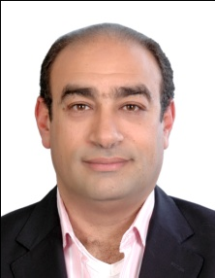 | Tel: +20 3 4250963  Fax: +20 3 4278931  Mobile: +20 122 2164838  heleinen@cegegypt.com  www.cegegypt.com  Alexandria | Sectors:Construction - Real Estate - Textile  Description:  -CEG is specialized in all sorts of construction work, building, structural engineering, electromechanical and Sport Courts contracting. Provide its services and carriers out turnkey projects to a variety of distinguished customers in different regions with ARE. In addition work in the Real Estate field via partnership contracts, constructing residential building, resorts etc.  -Targeting well established organizations, companies and factories as well as individuals customers with small and medium size projects  -Gomatex is an import/export company for cotton and textile trade with market expertise  Expected cooperation: Import Export – Investment opportunities – Joint venture  1. Seeking for an investor to invest in their three phase project resort in Hurghada, Red Sea “Kamareia resort” www.kamareiaresort.com.  2. company to market the same resort as summer homes for Europeans /  3. Seeking to export Egyptian cotton and textile.
 | Mr. Sherif Bahgat  Import & Export manager  Liteway Egypt  Contact language:  Arabic, English, Frensh  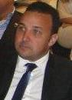 | Tel.: +20 2 46102236  Fax:.+20 2 46103176  Mobile: +20 122 3242118  sherif@liteway-lighting.com  Cairo | Sectors: Engineering Industry – Energy – Manufacturing  Description:Production, supply and trade of lamps, control gears and lighting fixtures for indoor and outdoor use. The company is in the Egyptian market from 1989, we have a turnover around 6 mUSD, we manufacture CFL lamps and well as assembly of lighting fixtures, we represent some majors company from the lighting field in the Egyptian market, we do lighting design and supply for A class projects in the Egyptian market and supply of Egyptian contractors working in the region.  Expected cooperation: Import Export – Investment opportunities – Joint venture
 | Mr. Ahmed Mashhour  -Managing Partner  Egyptian Consulting & Trading Company (ECTRA)  Sole Agent for Deutz Engines in Egypt  EJB Secretary General  Contact Language:  Arabic - English  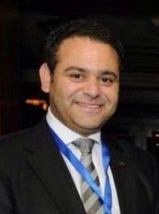 | Tel: +20 2 27363326  Fax: +20 2 27361582  Mobile: +20 122 2176389  info@ectra.com.eg  www.ectra.com.eg  Cairo | Sectors: Agriculture-Engineering-Automotive-Consultancy-Manufacturing  Description: Foreign Trading Agencies. General company’s overview and preferable with key indicator such as turnover, different lines of business, percentage of market share if available, how long has it been operational.  Expected cooperation: Import Export- Investment opportunities
 | Mr. Mohamed Ahmed Tera  -Board Member and Director of Trading  Tera Industrial Co. For Spinning & Knitting.  -EJB Treasurer  Language: Arabic- English  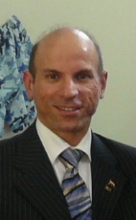 | Tel: +203 4590004  Fax: +203 4590003  Mobile: +20 122 2187889  info@teratexgroup.com  www.teratexgroup.com  Alexandria | Sectors: Textile  Description:  1.Spinning of Acrylic semi worsted yarns, Normal and High bulk, single and twisted, Rang of counts 6 Nm. to 5o Nm.  2.Spinning of O.E. yarns 100% cotton & cotton blended with (polyester, acrylic) counts 10 Ne. to 24 Ne.  3.spinning of yarn 100% Acrylic & Acrylic blended with ( wool , viscose )  4.Circular knitted fabrics (single jersey , single jersey with Lycra , interlock, Rip(1 *1 , 1*2 , 2*2 ) )  Expected cooperation: Import Export – Joint Venture
5. | Mr. Khaled Mekaty  Chairman  H M STONE Company  Former EJB Chairman  Contact Language:  Arabic/English  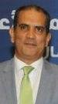 | Tel: +20227366274  Fax: +202 27365890  Mobile: +20 122 2105323  info@hmstone-eg.com  www.hmstone-eg.com  Cairo | Sectors: Construction-Building Materials-Manufacturing  Description: Production all kinds of marble and granite as well as export the production line to over 23 countries in the world  Expected cooperation: Exporting Marbles, seeking importers
6. | Mr. Khaled Khalil  -Partner and General Manager  Mahallatex for trading,  Industry and franchises.  -Former Director of EJB  International Relations  Contact Language: Arabic/English/French  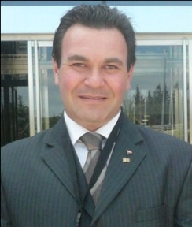 | Tel: 002 03 5411738  Fax: 002 03 5450771  Mobile: +20 122 2161215  khaled@mahallatex.com  www.mahallatex.com . www.carrera-protection.com | Sectors:Textile – Tourism - Consultancy - Food  Description: Production of Work wear and uniforms for workers and employees in cooperation with the Greek company "Calsta” under the new joint venture established in Egypt 2010 "Carrera protection", as an example: The uniform of the Athens Metro employees and some of the Greek fire department was produced by us. Another line is production, local distribution and export of ladies homewear, nightwear and lingerie.  Also, farms of citrus + Fruit juices.  Finally, organizing conferences, business and leisure trips.  Expected cooperation:  1-Seeking factories and companies employing more than 100 workers and employees to whom we can produce uniforms, especially in the field of Cement, Electricity, Fire departments, Food, and others.  2-We are also seeking distributors, importers or wholesalers who can distribute our ladies homewear, nightwear and lingerie products.  3-A joint venture with foreign investors is also welcomed if any interest to establish a factory for readymade garments in Egypt, to benefit from the incentives and privileges of Egypt in this regards.  4-organizing conferences, business and leisure trips.  5 Exporting juices, seeking importers
7. | Bassem Elghity  International Marketing Manager  NID Medical Co.  Contact Language:  Arabic/English  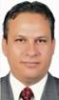 | Tel: +201223909618  Fax: +2035823228  Mobile +20 122 3909618  info@nid-medical.com  www.nid-medical.com  Alexandria | Sectors: Healthcare  Description: Manufacturer of Medical Disposables  Expected cooperation: Importing- Exporting Medical products and OEM ready
8. | Hany El Habibi  CEO of Sahara Group  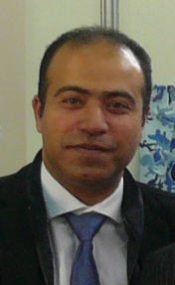  Gerta Mamaj  CEO Marketing – Sahara Group  Contact Language:  Arabic / English | Tel: +202 26708995  Mobile:+20 100 1007526  Mobile: +20 100 1007525  hany@saharagroup.com  www.egytex.com, www.saharagroup.com  Cairo | Sectors: Textile – Consultancy – Finance & Banking – Information technology – Manufacturing.  Description: Sahara Group, the leading Marketing & Consulting entity to the Textile Industry in Egypt. A multitask company operating in Egypt since 1995 with its fitting developing programs, by offering great instrumental opportunities in assisting the modernization of the Egyptian Textile Industry. Sahara Group is comprised of a web of industry-specific professionals in the areas of Consultation, Training, Quality Assurance, Marketing and Export Promotion. In a united framework, the group represents a complete eye on the industry concerns and subsequently provides holistic and concrete business solutions. The professionals that represent the various corners of the Group are accredited in their abilities to develop and move the Industry mechanics on both micro and macro levels in order to help the Egyptian Textile and Apparel Industry compete head to head in the World Textile arena.  Expected cooperation: Import-Export, Investment opportunities – Joint venture
 | Tamer Shafik  Business Development Director  Orascom Construction  Contact Language:  Arabic – English | Tel.: +202 2461 1020  Fax:+202 2461 9430  Mobile: +20 122 2393712  tamer.shafik@orascomci.com  www.orascomci.com  Cairo | Sectors: Construction  Description: Orascom Construction is a leading engineering, procurement and construction contractor active in emerging markets across the Middle East and North Africa. OC provides services on large, complex and demanding industrial, energy, commercial, water/sewage, transportation, telecommunications, maritime, tourism and railway projects for private and public customers. OC has earned a reputation for delivering quality work under difficult conditions, on schedule and at competitive prices. OC is present through regional offices in Abu Dhabi, Algeria, Bahrain, Qatar, Nigeria, Pakistan, Saudi Arabia, and Syria.  Our construction group ranks among the world's top global contractors. For more than 10 years, Orascom Construction have played a leading role in energy, fertilizer, oil & gas projects intended to support growth in emerging markets – completing an impressive list of plants across northern and western Africa.  Expected cooperation: Having meetings for the following sectors: Construction, Consultancy, Engineering Industry, Energy, Finance & Banking, Information Technology,
 | Mahmoud Medhat El Kady  Kadmar Group  Business Development Manager  Languages: Arabic – English  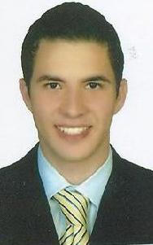 | Tel.: +203 4840680  Fax: +2034848326  Mobile: +20 122 2268016  general@kadmar.com  mahmoud@kadmar.com  www.kadmargroup.com  Alexandria | Sectors: Shipping –logistics- Travel  Description:  1 - Kadmar Shipping Co.  Shipping Agency, Suez Canal Passage, Ship brokerage and Chartering- Ships supplies, Loading and discharging ,Marine and cargo Survey, Ships repairs& maintenance& performing supervising& special maritime operations.  2 - Egyptian Global Logistics (EGL)  Sea freight - Air freight - Inland Trucking  Storage of goods containers within and outside ports through the open and covered stores at both the port of Alexandria and Damietta, and at the city of Alexandria, the total area of 25000 square meters, Integrated services for cargo and projects from place of receipt to the place of delivery CONTRACT LOGISTICS PROJECTS  Customs clearance. Packaging of goods  3 - Kadmar Travel Company  Airline and Ferries tickets- Hotels booking -  Organizing internal and external trips, Hajj and Umrah transportation, conferences and exhibitions.  4- Kadmar Logistics  Logistics, Warehousing-Ship supply management - trucking  Expected cooperation: Import-export, joint venture and franchise , Ropax line - Joint venture with specialized company in international trucking and transportation services.- Joint venture with EU partners- Joint venture with EU partners in logistics & Travel platform

