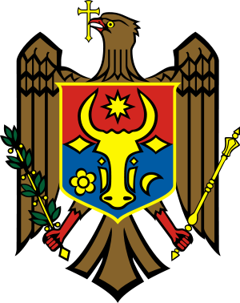 | 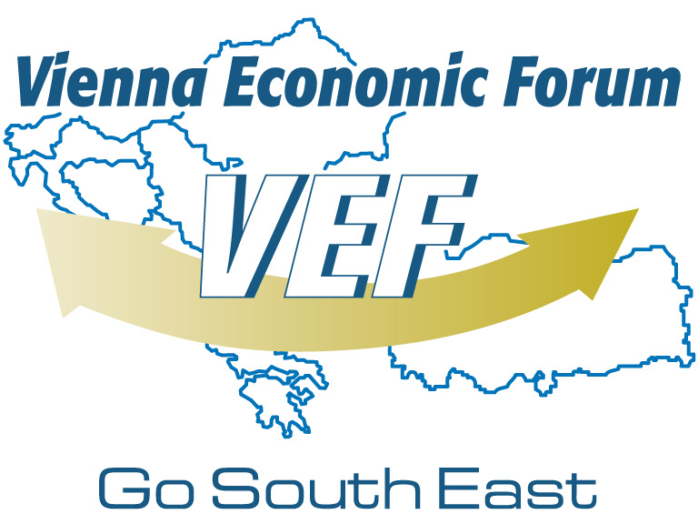 | 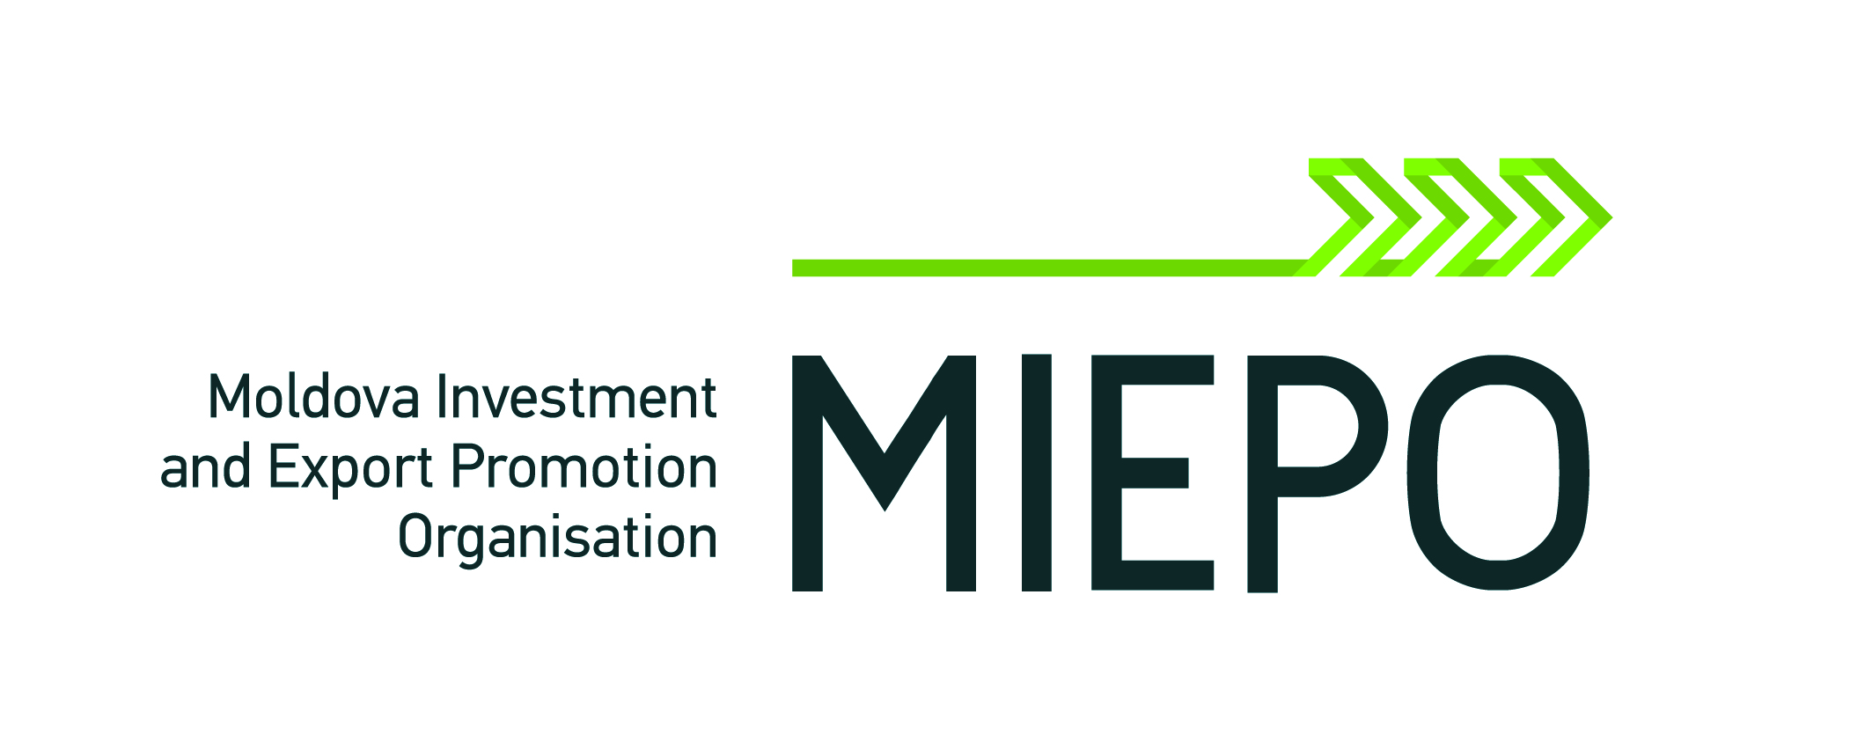  VIENNA ECONOMIC TALKS –  CHISINAU MEETING 2014  10-11 June 2014  Leogrand Convention Centre,  Chisinau, Moldova

Application Form
Please type the application to ensure your organisational information is represented accurately in our database system
Please note that this is how you will be indicated on your badge and the list of participants

Personal Information
 | □ Mr. | □ Ms. | Academic Title
First Name |  |  | Last Name
E-Mail

Corporate Information
Company Name |  |  | Position
Country |  | Website

Please note that this is how you will be indicated on your badge and the list of participants.

□ Yes, I will participate at Vienna Economic Talks – CHISINAU MEETING 2014
□ 10 June 2014
□ 11 June 2014
□ Yes, I am interested in bilateral talks at Vienna Economic Talks – CHISINAU MEETING 2014 on 11 June 2014
□ Yes, I will participate in the Investment Conference, organised by European External Action Service - European Neighbourhood Policy Division, Brussels and the EU Delegation to Moldova, with H.E. Jose Manuel Barroso, on 12 June 2014

There is no participation fee for this event. Please note that delegates are responsible
for the arrangement and payment of their own travel and accommodation.

I hereby certify that the information provided in this application is accurate and complete. I understand that the partners of Vienna Economic Talks – CHISINAU MEETING 2014 will be informed about my application and attendance and I consent to these terms.

Date |  | Signature
Please return the signed form by 3 June 2014
Vienna Economic Forum
Stubenring 16/3, 1010 Vienna, Austria
Tel: + 43 (1) 714 10 14 • Fax: + 43 (1) 714 10 14 - 19
E-Mail: office@vienna-economic-forum.com

