  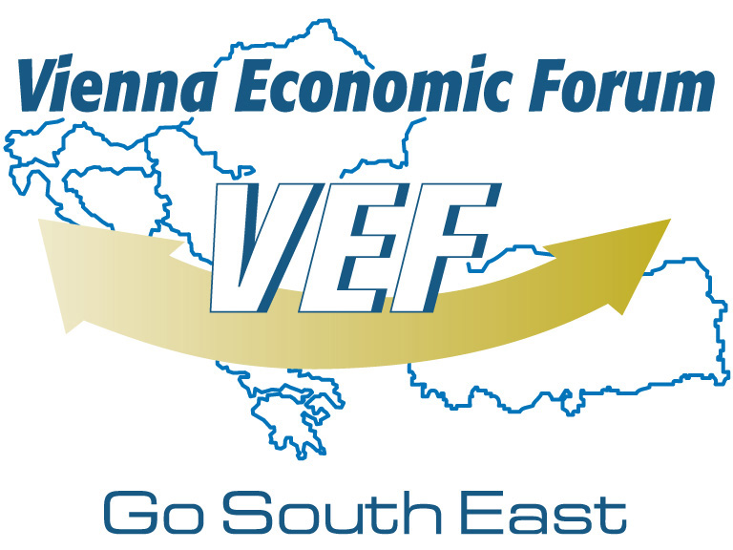  Application Form | VIENNA ECONOMIC TALKS -  Sofia Meeting  Location: Bulgarian Chamber of Commerce and Industry,  Iskar Street 9, 1058 Sofia  3-4 April 2012  Sofia

Please type the application to ensure your organizational information is represented accurately in our database system

Organization Information
Name
Country |  | Website

Please note that this is how you will be indicated on your badge and the list of participants.

Personal Information
 | □ Mr. | □ Ms. | Academic Title
First Name |  |  | Last Name
E-Mail

□ Yes, I will participate at Vienna Economic Talks – Sofia Meeting on 4 April 2012
There is no participation fee for this event. Please note that delegates are responsible
for the arrangement and payment of their own travel and accommodation.

I hereby certify that the information provided in this application is accurate and complete. I understand that the partners of Vienna Economic Talks – Sofia Meeting will be informed about my application and attendance and I consent to these terms.

Date |  | Signature
Please return the signed form latest by 23 March 2012
Bulgarian Chamber of Commerce and Industry
9, Iskar Str. 1058 Sofia, Bulgaria
Tel: + 359 2 81 17 489. 81 17 421. 81 17 497 • Fax: + 358 2 987 32 09
E-Mail: g.dimitrova@bcci.bg

