3L741series
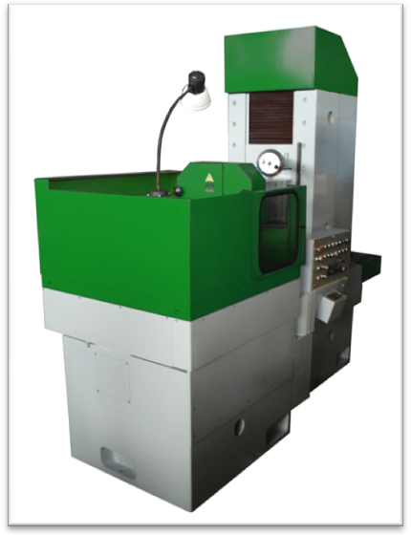
The machine is designed for high-accuracy grinding of ferromagnetic parts by wheel face. It complies with strict requirements of surface finish, parallelism and accuracy.

Features
- The machine allows to grind flat, convex and concave surfaces.
- The machine is equipped with the system of stable outer speed in the zone of grinding and stable feed per table rotation, providing high accuracy and easy work, the same good quality of finishing on the whole table surface and high productivity.
- High wear resistance and accuracy is provided by roller guideways.
Specification | 3L741V(А)F10 | 3L741VF10-800
Workpiece
Workpiece dimensions  - height  - diameter  - while working with a small-pole plate  - minimal height  - minimal diameter | 4…350  50…660  1  10 | 4…350  50…800  1  10
Maximum workpiece weight, kg | 300
Machine
Diameter of table working surface, mm | 630 | 800
Frequency of spindle rotation, r/min | 1460
Frequency of table rotation, r/min | 8-32 |  | 6-24
Maximum column travel, mm | 430
Maximum vertical travel of wheel head, mm | 415
Rapid cross column travel, mm/min | 120
Rapid vertical travel of wheel head, mm/min | 200
Automatic vertical feed of wheel head, mcm | 1; 2; 4; 8; 12; 16; 24; 48
Main workpiece rotation drive power, kW | 4
Main wheel head drive power, kW | 11
Total power of machine electric motors, kW | 18
Tools
Grinding wheel dimensions under GOST 52781-2007, mm | 450х80х203
Dimensions and weight
Dimensions (LxBxH), mm | 2860х2730х2660
Weight, kg | 5460 | 5740
Accuracy parameters for test piece
Working accuracy:  - flatness, mcm  - parallelism, mcm  - surface roughness, mcm | 4  4  0,25 | 6  6  0,5

