Magnetic and Electromagnetic Plates
by Lipetsk Machine-Tool Plant
Magnetic and electromagnetic plates are designed for fixing ferromagnetic workpieces during their processing (fitting and other operations)on metal working machines. There are magnetic, small-pole magnetic and magnetic sine swivel plates of all sizes.
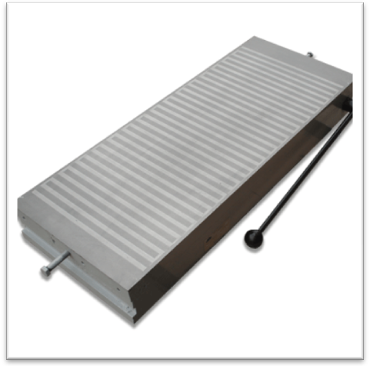

Magnetic Plates
Sizes, cm | From 100x250 up to 320x1000
Attractive force at full load, N/cm² | 60
Small-Pole Magnetic Plates
Sizes, cm | From 100x250 up to 320x1000
Attractive force at full load, N/cm² | 100
Magnetic Sine Swivel Plates
Working surface dimensions | From 125x400 up to 200x630
Attractive force at full load, N/cm² | 100

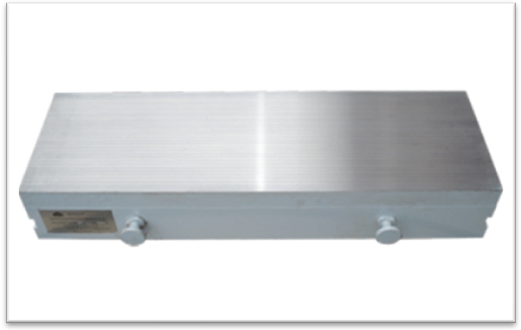

Rectangular Electromagnetic Plates
Sizes, cm | From 200x450 up to 630x2000
Attractive force at full load, N/cm² | 60
Round Small-Pole Electromagnetic Plates
Sizes, cm | From D=630 up to D=1000
Attractive force at full load, N/cm² | 80
Small-Pole Electromagnetic Plates
Sizes, cm | From 125x400 up to 630x2000
Attractive force at full load, N/cm² | 80

