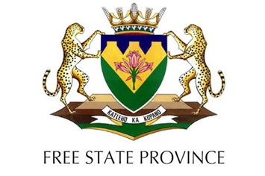

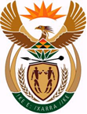

Bulgarian Chamber of Commerce and Industry (BCCI) Embassy of the Republic of South Africa

REGISTRATION FORM
Investment Seminar titled:
“Huge Investment Opportunities in the Free State Province of South Africa”
13 September 2016
(13:00 hrs to 16:00 hrs)
Hotel Marinela Sofia (Sofia Hall), 100 James Bourchier Blvd, Sofia
Name:

Company:

Contact details: Tel No:
E-mail address:
Postal address:

Sector of industry:

