European Commission

Press release
Brussels, 12 May 2014
Eurobarometer survey: trust and optimism are growing across the European Union
According to a Special Eurobarometer survey "Europeans 2014" published today, a majority of Europeans say that they have a positive image of the EU (34% which is +3 percentage points [pp] compared to the Standard Autumn Eurobarometer released in November 2013 - compared to 26% who say they have a negative image of the EU
There is also growing optimism with regards to (1) the economic outlook in Europe and (2) towards Europe's future. Europeans in 20 out of 28 Member States say they expect the economic situation in their home country to improve in the coming twelve months.
1. Perception of the economic outlook in Europe is improving:
There has been a 5 pp rise in the number of citizens who think the economic situation in their home country will be better or the same in the coming twelve months, which is matched by a sharp decline in the pessimism regarding economic expectations (see Annex 1).
Moreover, when asked whether the impact of the crisis on jobs has already reached its peak, 44% agree, which is a 4pp rise since the autumn 2013 survey (see Annex 2). Challenges remain, however: Nearly half of Europeans (49%) believe that unemployment is the most important issue their country is facing at the moment (see Annex 3).
2. Trust in the EU on the rise as more people feel their voice counts
Trust towards the EU is on the rise (32%, +1pp) and continues to be above trust towards national parliaments (27%, -2pp) and the national government (26%, +3 pp) (see Annex 4). At the same time over half of Europeans (53%) say that they are positive about the future of the EU (see Annex 5).
These findings suggest that the considerable efforts by the Commission to reach out to citizens are paying off. It has for example organised 51 Citizens' Dialogues across Europe and sought to make the upcoming European Parliament elections even more relevant to citizens by recommending political parties to nominate lead candidates (see IP/14/321). The Eurobarometer published today shows that more people believe that their voice counts in the EU: 37% compared to 29% in autumn 2013. This is one of the highest increases in such a period of time for the past ten years (see Annex 6).
Background
The Special Eurobarometer published today is based on a representative sample of people from all 28 Member States of the European Union. In total almost 28.000 citizens aged 15 and older were interviewed between 15 and 24 March 2014.
Further information
The Special Eurobarometer survey 415 published today outlines Europeans' perception of the current economic situation in the European Union, their main concerns and trust in political institutions. It is the only European-wide survey.
The results, as well as national factsheets (in English), are available at:
http://ec.europa.eu/public_opinion/archives/eb_special_419_400_en.htm#415

Contacts :
Mina Andreeva (+32 2 299 13 82)
Joshua Salsby (+32 2 297 24 59)
For the public: Europe Direct by phone 00 800 6 7 8 9 10 11 or by email

Annex
1. Expectations about the national economy: perceptions are improving in 20 EU countries
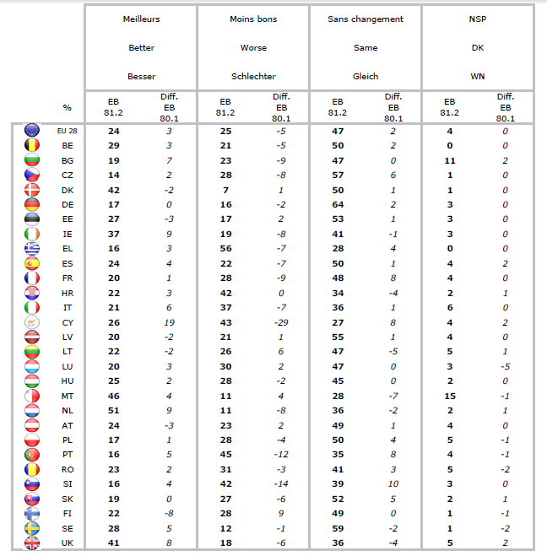
2. Impact of the crisis: Optimism continues to rise
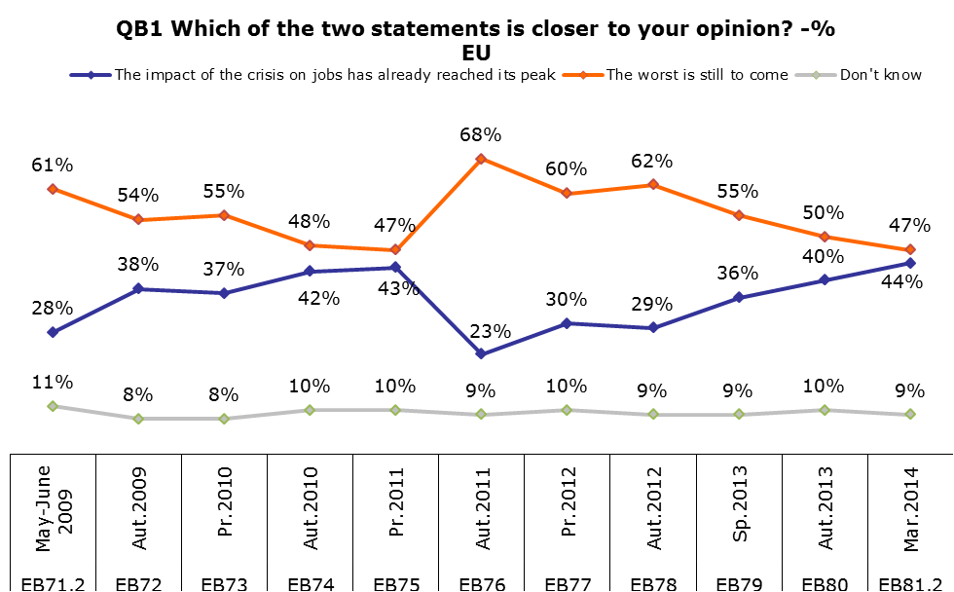
3. Unemployment remains the main national concern
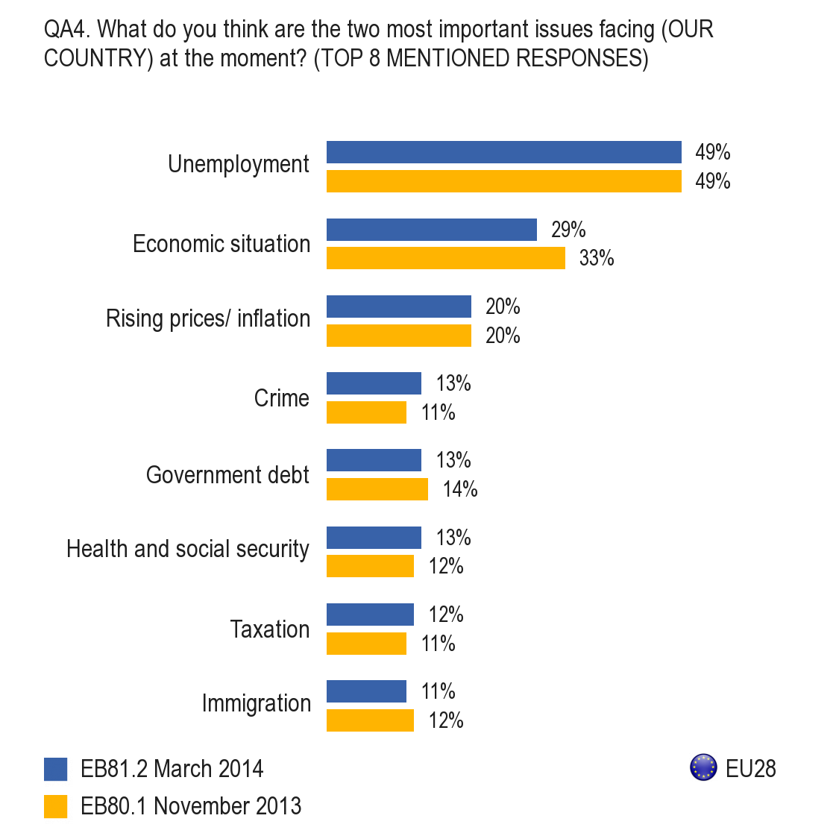
4. Trust towards the EU on the rise and above national institutions
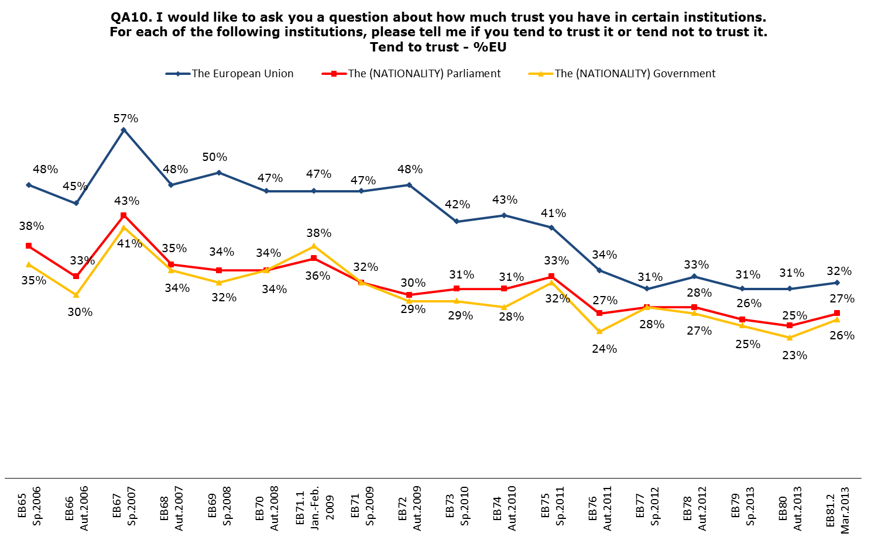

5. Citizens in 22 EU countries are positive about the future of the EU
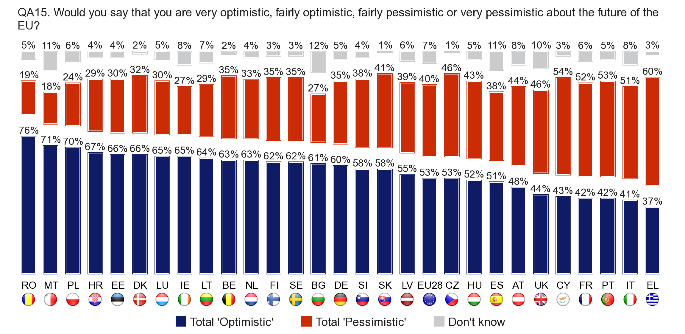
6. "My voice counts in the EU": Highest Increase in 10 years
