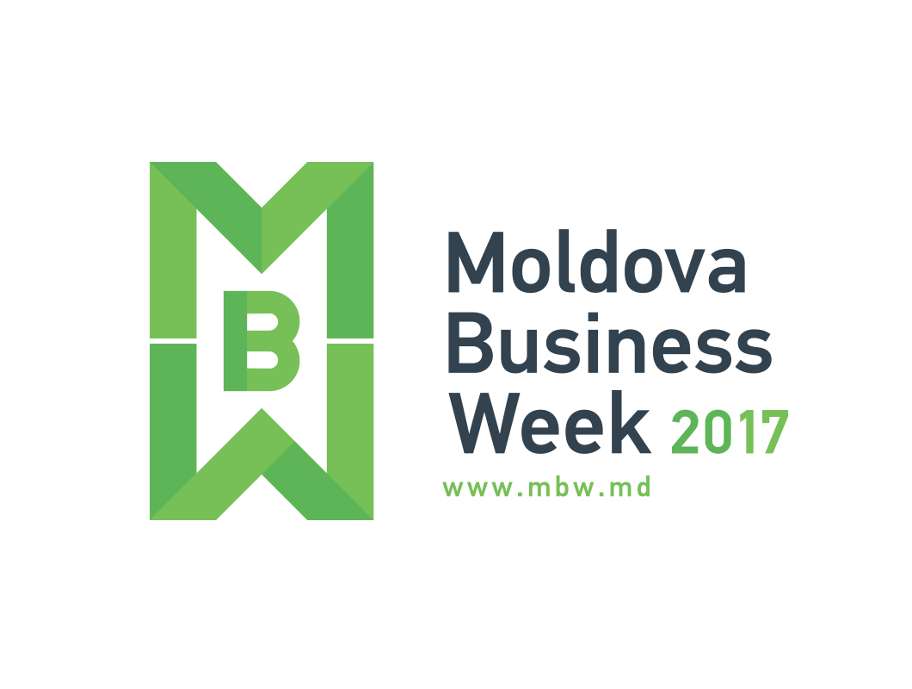

Moldova Business Week” represents one of the most important business events of the Republic of Moldova dedicated to promote the country’s image at the international level, ensure intensification and transparency of the public – private dialogue, increase the competitiveness of Moldovan companies, as well as investment and export promotion.
”Moldova Business Week 2017” will be an event that will strengthen the government’s position as an executive providing support to the national and international businesses, as well as development of the business and investment climate for the national and international community.
Furthermore, the event is a priority action for 2017, established in agenda of the Ministry of Economy and Infrastructure of the Republic of Moldova and Moldova Investment and Export Promotion Organisation (MIEPO).
The fourth edition of the „Moldova Business Week 2016” will take place in the period of 3-6 October 2017, under the aegis of the Prime Minister of the Republic of Moldova, Mr. Pavel Filip. Participation at „Moldova Business Week 2017” is free of charge and can be confirmed through the website www.mbw.md .
According to the governmental development program, the concept of “Moldova Business Week 2017” will be focused on promoting Moldova’s image as a reliable business partner. In detail, the concept will be divided on three priority directions, as follow:

”Moldova Business Week 2017”
AGENDA
DATE | EVENT |  | ORGANIZER
2 October  (Monday) | ”Moldova Business Week 2017” Launching Press Conference |  | Ministry of Economy and Infrastructure of the Republic of Moldova  Moldova Investment and Export Promotion Organisation (MIEPO)
3 October  (Tuesday) | ”Moldova Business Week 2017” Official Opening  ”Invest in Moldova 2017”,  Day 1 | PARALLEL SESSIONS: | Moldova Investment and Export Promotion Organisation (MIEPO)  Economic Policy Advice to the Moldovan Government (GIZ)  Public Property Agency
 |  | Free Economic Zones and Industrial Parks – the place to grow your business
 |  | Moldovan Agriculture and Food Processing Sector Opportunities
 |  | Moldovan Manufacturing Sector – Textile, Apparel, Footwear and Leather Goods
 |  | Moldovan Privatization Assets
 |  | ICT Sector Track– Attracting Investment
4 October  (Wednesday) | ”Invest in Moldova 2017”,  Day 2 | Study visits into the regions | Moldova Investment and Export Promotion Organisation (MIEPO)  Economic Policy Advice to the Moldovan Government (GIZ)
 |  | Moldovan – Italian Business Forum | Moldo - Italian Chamber of Commerce and Industry
 |  | Launching the Project ”Online Platform – Moldovan ECO Products” | Moldova Business People Association (MBPA)
5 October  (Thursday) | ProExport Forum 2017 |  | Ministry of Economy and Infrastructure of the Republic of Moldova  Moldova Investment and Export Promotion Organisation (MIEPO)
6 October  (Friday) | International Conference of the Small and Medium Sized Enterprises |  | Organization for the Development of the Small and Medium Sized Enterprises (ODIMM)
 | ”Moldova Business Week 2017” Closing Press Conference |  | Ministry of Economy and Infrastructure of the Republic of Moldova and Working group
 | Closing reception of ”Moldova Business Week 2017” |  | Moldova Investment and Export Promotion Organisation (MIEPO)

2nd OCTOBER, MONDAY

”MOLDOVA BUSINESS WEEK 2017” LAUNCHING PRESS CONFERENCE
Ministry of Economy and Infrastructure of the Republic of Moldova| 10:00
- Octavian CALMÎC, Minister of Economy and Infrastructure of the Republic of Moldova
- Vitalie ZAHARIA, General Director of Moldova Investment and Export Promotion Organisation (MIEPO)

3rd OCTOBER, TUESDAY

”MOLDOVA BUSINESS WEEK 2017” OFFICIAL OPENING
”INVEST IN MOLDOVA 2017”, DAY 1
Radisson Blu Leogrand Convention Center | 08:30 – 17:00
08:30 – 09:30 | Registration of the participants&Welcoming Coffee
”MOLDOVA BUSINESS WEEK 2017” OFFICIAL OPENING
09:30 – 10:00 | WELCOMING REMARKS
- Pavel FILIP, Prime-minister of the Republic of Moldova (tbc)
- Head of the European Union Delegation to the Republic of Moldova (tbc)
”INVEST IN MOLDOVA 2017”
10:00 – 12:00 | PANEL I  BUSINESS AND INVESTMENT OPPORTUNITIES OF THE REPUBLIC OF MOLDOVA
- Business climate of the Republic of Moldova, Octavian CALMÎC, Minister of Economy and Infrastructure of the Republic of Moldova
- One Stop Shop – support to the investors’ companies, Vitalie ZAHARIA, General Director of the Moldova Investment and Export Promotion Organisation (MIEPO)
- Dual education system of the Republic of Moldova – potential and perspectives, Viorelia MOLDOVAN-BĂTRÂNAC, Counsellor of the Prime-Minister’s Cabinet (tbc)
- Foreign Investment – Regional Competitiveness of the Republic of Moldova, Sergiu CIOCLEA, Governor of the National Bank of Moldova (tbc)
- Strengthening the national legislation as a platform to improve investment climate, Vladimir CEBOTARI, Minister of Justice of the Republic of Moldova (tbc)
- Labor force potential in the Republic of Moldova’s regions, Raisa DOGARU, Director of National Labor Employment Agency of the Republic of Moldova (tbc)
- Legal framework for foreigners – working and living permits, Mihail BEREGOI, State Secretary, Ministry of Internal Affairs of the Republic of Moldova (tbc)
- Financial Instruments for private sector, European Bank for Reconstruction and Development, World Bank

Moderator – Alexander KOSS, President of Foreign Investors Association (tbd)
12:00 – 13:30 | Lunch & Networking
13:30 – 16:00 | PANEL II  PARALLEL THEMATIC SESSIONS
SESSION I | FREE ECONOMIC ZONES AND INDUSTRIAL PARKS – THE PLACE TO GROW YOUR BUSINESS
- Free Economic Zones and Industrial Parks – investment opportunities, Vitalie IURCU, Deputy Minister of Economy and Infrastructure of the Republic of Moldova
- Foreign investors and dual education. Case studies, Marin CIOBANU, Administrator of Free Economic Zone Balti
- Success stories:
- La Triveneta Cavi Development (Italy) - production of insulated electrical cables of medium and low tension voltage
- GG Cables&Wires EE (Austria) – production of insulated electrical cables for automotive industry
- Elektromanufacturing (Romania) – production of insulated electrical equipment of medium and low tension voltage (tbc)
- Black Sea EMS (Netherlands) - LED lighting control systems (tbc)

- Business to Business Networking & Coffee
Moderator: Ronny BECHMANN, Sustainable Economic Development Program Manager, GIZ
SESSION II | MOLDOVAN AGRICULTURE AND FOOD PROCESSING SECTOR OPPORTUNITIES
- Overview of the Moldovan Agri-Food sector and harmonization of the legislation, Ministry of Agriculture, Regional Development and Environment of the Republic of Moldova
- Subsidies Regulation: statistics and results, Nicolae CIUBUC, Director of Agency for Agricultural Interventions and Payments
- Investment projects in Agri-Food sector, Maxim POPOV, Agri-Food Expert, Moldova Investment and Export Promotion Organisation (MIEPO)
- Success stories:
- ”Moldova Fruct” Association, Vitalie GORINCIOI, President of “MOLDOVA FRUCT” Association
- National Office for Vine and Wine, Gheorghe ARPINTIN, Director of the National Office for Vine and Wine

- Business to Business Networking

Moderator: H.E. Vasile BUMACOV, Ambassador Extraordinary and Plenipotentiary of the Republic of Moldova to Japan
SESSION III | MOLDOVAN MANUFACTURING SECTOR – TEXTILE, APPAREL, FOOTWEAR AND LEATHER GOODS (TAFL)
- Overview of Moldovan Textile, Apparel, Footwear and Leather Goods Sector, Moldova Investment and Export Promotion Organisation (MIEPO)
- Evolution of Moldovan companies development: ”Din Inimă (From the heart)” Brand and ZipHouse Center of Excellence, Employers' Association of Light Industry (APIUS)
- Labor force potential and education system in the sector – colleges and universities, Maria GHEORGHITA, Faculty of Light Industry, Technical University of Moldova
- Success stories:
- Foreign Investors (Euroyarns);
- Local companies (Intercenter Lux);

- Business to Business Networking

Moderator: Doina NISTOR, Director of the Competitiveness Enhancement Project (USAID) (tbc)

SESSION IV | MOLDOVAN PRIVATIZATION ASSETS
- Presentation of the privatization assets:
- National strategic assets
- General public property assets

- Business to Business Networking

Moderators – Alina BOTAN, Head of the Privatization Department, Agency for Public Property,
Augustin RABEI, Informational Technologies and Business Process Outsourcing Sector Expert, Moldova Investment and Export Promotion Organisation (MIEPO)
SESSION V | ICT SECTOR TRACK – ATTRACTING INVESTMENT
- Presentation of the privatization assets:
- Fiscal Facilities
- Startup Visa
- IT Parks
- ICT Human Capital
- Success stories:
- Endava
- Pentalog
- Future plans

Moderator – Ana CHIRITA, Executive Director, Moldovan Association of ICT Companies (tbc)

4th OCTOBER, WEDNESDAY

”INVEST IN MOLDOVA 2017”, DAY 2
09:00 – 17:00 | STUDY VISITS INTO REGIONS
STUDY VISIT FOR THE SESSION I
FREE ECONOMIC ZONES AND INDUSTRIAL PARKS – THE PLACE TO GROW YOUR BUSINESS
- Free Economic Zone “Balti”, Subzone 3 Balti city – Gebauer&Griller (tbc)
- Free Economic Zone “Balti”, Subzone Straseni – La Triveneta Cavi Development (wire harnesses)

Moderator: Vasile SOLDAN, Investment Attraction Expert, Moldova Investment and Export Promotion Organisation (MIEPO)
STUDY VISIT FOR THE SESSION II
MOLDOVAN AGICULTURE AND FOOD PROCESSING SECTOR OPPORTUNITIES
Visits to the following companies:
- Elit-Fruct (orchard)
- Mezelini (processed meat factory)
- Orhei-Vit (canned food plant)
- Chateau Vartely Winery
- Costesti Line Production

Moderators: Maxim POPOV, Agri-Food Expert and Anastasia UNGUREANU, Agri-Food Manager, Moldova Investment and Export Promotion Organisation (MIEPO)
STUDY VISIT FOR THE SESSION III
MOLDOVAN MANUFACTURING SECTOR – TEXTILE, APPAREL, FOOTWEAR & LEATHER GOODS
- Ponti (manufacturing of tights, socks, and other accessories)
- Steaua Reds (knitwear production)

Moderators: Irina Todorova, Textile, Apparel, Footwear and Leather Goods Sector Consultant, Moldova Investment and Export Promotion Organisation (MIEPO) and Diana Durnescu, Business Development Manager, Economic Policy Advice to the Moldovan Government (GIZ)

MOLDOVAN – ITALIAN BUSINESS FORUM
09:30 – 09:50 | WELCOMING REMARKS
- H.E. Valeria BIAGIOTTI, Ambassador Extraordinary and Plenipotentiary of the Republic of Italy to the Republic of Moldova
- Octavian CALMÎC, Minister of Economy and Infrastructure of the Republic of Moldova
09:30 – 09:50 | PANEL I
- Italian presence in the Republic of Moldova, Mauro SALVATORI, President of the Moldo-Italian Chamber of Commerce and Industry
- Italian presence in the Republic of Moldova, Sergio CAPATTI, President of the Italian-Moldovan Chamber of Commerce and Industry
- Banking system of the Republic of Moldova, Sergiu CIOCLEA, Governor of the National Bank of Moldova
- Investment opportunities of the Republic of Moldova, Vitalie ZAHARIA, General Director of the Moldova Investment and Export Promotion Organisation (MIEPO) (tbd)
- EXIMBANK – Intesa Sanpaolo Group – Banking services for enterprises, Eximbank – Intesa Sanpaolo Group
- Free Trade Agreement European Union – Republic of Moldova (DCFTA) and support tools for investment, Peter MICHALKO, European Union Delegation to the Republic of Moldova
- The facilities offered by Free Economic Zones (tbc)
- Success stories
- Company suggested by Moldo-Italian Chamber of Commerce and Industry (tbd)
- Company suggested by Italian-Moldovan Chamber of Commerce and Industry (tbd)
- Questions and Answers

Moderator – H.E. Valeria BIAGIOTTI, Ambassador Extraordinary and Plenipotentiary of the Republic of Italy to the Republic of Moldova
12:00 – 12:15 | Networking & Coffee Break
12:15 – 13:00 | THEMATIC SESSIONS
- Iurie CEBAN, Customs Service of the Republic of Moldova
- Serghei PUSCUTA, State Tax Inspectorate of the Republic of Moldova
- Olga POALELUNGI, Migration and Asylum Bureau, Ministry of Internal Affairs of the Republic of the Republic of Moldova
Table 1: The main customs rules and procedures. Customs Service of the Republic of Moldova
Table 2: Fiscal facilities for investment. State Tax Inspectorate of the Republic of Moldova
Table 3: Simplified procedures for investors’ residence permits. Migration and Asylum Bureau
18:00 – 20:00 | RECEPTION AT RESIDENCY OF H.E. VALERIA BIAGIOTTI, AMBASSADOR EXTRAORDINARY AND PLENIPOTENTIARY OF THE REPUBLIC OF ITALY TO THE REPUBLIC OF MOLDOVA  (by invitations)

LAUNCHING THE PROJECT ”ONLINE PLATFORM – MOLDOVAN ECO PRODUCTS”
The goal of the project is to provide infrastructure for promotion of organic products, the interaction between producers and consumers for providing on-line traditional and ecological products, as well as digital content and other related information.

5th OCTOBER, THURSDAY

PROEXPORT FORUM 2017
Radisson Blu Leogrand Convention Center | 08:30 – 16:00
08:30 – 09:30 | Registration of the participants & Welcoming Coffee
09:30 – 10:00 | WELCOMING REMARKS
- Pavel FILIP, Prime-minister of the Republic of Moldova (tbc)
- Octavian CALMÎC, Minister of Economy and Infrastructure of the Republic of Moldova
- Head of the European Union Delegation to the Republic of Moldova (tbc)
10:00 – 11:30 | PANEL I  REALITIES AND PERSPECTIVES OF THE MOLDOVAN EXPORT DEVELOPMENT
- Presentation of the current situation and perspectives of the domestic export, Vitalie IURCU, Deputy Minister of Economy and Infrastructure of the Republic of Moldova
- Support for Moldovan exporters, Vitalie ZAHARIA, General Director of the Moldova Investment and Export Promotion Organisation (MIEPO)
- Developing capacities of domestic exporters – USAID, Sergiu BOTEZATU, USAID Moldova Superior Project Manager
- Support and success stories in the field of export:
- Gheorghe ARPENTIN, Director of the National Office for Vine and Wine
- Iurie FALA, Executive Director of the ”Moldova Fruct” Association
- Marina LAPUSNEANU, Executive Director, Employers' Association of the Light Industry
- Ion TORNEA, Executive Director of Manufacturing Employers' Association
- Opportunities for internationalization of trade:
- Asia, China – Free Economic Zone “Khorgos”/HUNAN MARKET
- European Union, Romania, Modern Buyers – distribution networks
- European Union, Great Britain, Trigon Select

11:30 – 12:30 | Lunch Fourchette & Networking
12:30 – 13:30 | PANEL II  MASTER-CLASS EXPORT PROMOTION
 | Master – class in the field of export promotion
13:30 – 16:00 | PANEL III  BUSINESS TO BUSINESS SESSION&COFFEE
 | Session between Moldovan and foreign companies (potential buyers or business partners from abroad). Implication of Modern Buyers (Kaufland, HoReCa, distributors, networks, multisectorial companies from Romania), Trigon Select, Bilateral Chambers of Comerce.

6th OCTOBER, FRIDAY

INTERNATIONAL CONFERENCE OF THE SMALL AND MEDIUM SIZED ENTERPRISES
Blu Leogrand Convention Center |09:30 – 15:00
09:30 – 10:00 | Registration of the participants & Welcoming Coffee
10:00 – 10:30 | WELCOMING REMARKS
- Pavel FILIP, Prime Minister of the Republic of Moldova
- Octavian CALMÎC, Minister of Economy and Infrastructure of the Republic of Moldova
- Head of the European Union Delegation to the Republic of Moldova (tbc)
10:30 – 12:00 | PANEL I
- Sustainable and competitive economic development of the Republic of Moldova, Octavian CALMÎC, Minister of Economy and Infrastructure of the Republic of Moldova
- Mapping and identification of Moldova regional potential, Hugo HOLLANDRES/Ales GNAMUS, S3 Expert (tbc)
- Services for enhancing competitiveness and intelligent specialization in the Republic of Moldova, Gabriela MACOVEIU, North-East Regional Development Agency, Romania (tbc)
- Questions and Answers
12:00 – 13:00 | Lunch Break
13:00 – 14:00 | PANEL II
- Exploration of the small and medium-sized enterprises support tools at the regional level, Iulia IABANJI, General Director of the Organization for the Development of the Small and Medium Sized Enterprises (ODIMM)
- Intelligent specialization - a tool for creating and promoting regional competitive advantage (tbc)
- Closing and Conclusions
14:00 – 15:00 | AWARD CEREMONY OF NATIONAL CONTESTS
- Competition ” Best Entrepreneur in the small and medium-sized enterprises sector”
- National Contest ”Small and medium-sized enterprises - social responsibility model”

”MOLDOVA BUSINESS WEEK 2017” CLOSING PRESS CONFERENCE
Ministry of Economy and Infrastructure of the Republic of Moldova | 14:00
Closing Press Conference of Moldova Business Week 2017 – results and perspectives:
- Octavian CALMÎC, Minister of Economy and Infrastructure of the Republic of Moldova
- Vitalie ZAHARIA, General Director of the Moldova Investment and Export Promotion Organisation (MIEPO)
- Organizational Committee of the ”Moldova Business Week 2017”

”MOLDOVA BUSINESS WEEK 2017” CLOSING RECEPTION (by invitation)
Venue – tbd
19:00

