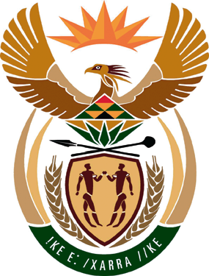
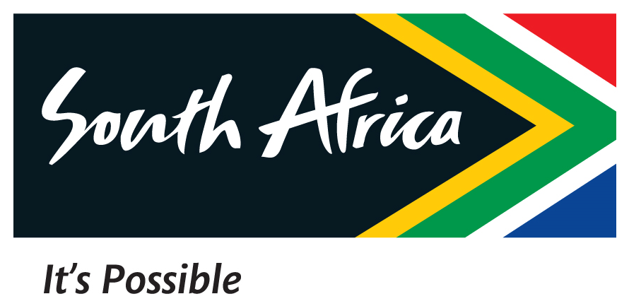
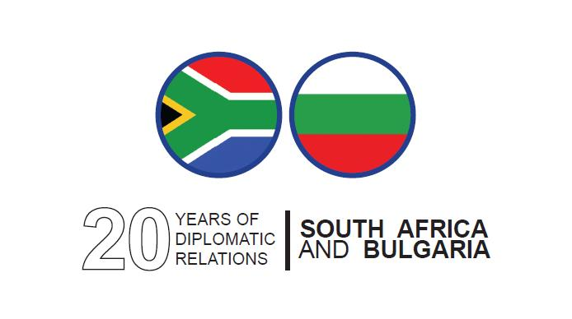

PROGRAMME

south african BUSINESS forum – SOFIA, BULGARIA

08 NOVEMBER 2012

09h30 - 10h00: Registration of delegates
Coffee/Rooibos tea

10h00 – 10h15: Opening & Welcoming of Delegates
Mr. B Motloung

Counsellor – South African Embassy to Bulgaria
and
Brand South Africa Video

10h15 – 10h25: HE SM Camerer
Ambassador of Republic of South Africa to Bulgaria
introduces Ambassador MM Mpahlwa – South African Ambassador to the Russian Federation

10h25 – 11h05: Key Note Address / Presentation
HE MM Mpahlwa
Ambassador of Republic of South Africa to Russia

11h05 – 11h25: Mr. Vusi Mweli
Minister-Counsellor for Trade and Industry – South Africa Embassy to the Russian Federation

11h25 – 12h00: Opportunity for remarks by Bulgarian Business and Q& A

South African Wine Tasting

