

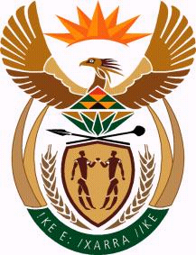

Draft PROGRAMME

south african TOURISM DAY SEMINAR – SOFIA, BULGARIA

25 OCTOBER 2013

(vENUE: bULGARIAN cHAMBER OF COMMERCE AND INDUSTRY – 9, ISKAR STREET, SOFIA)
(As guests arrive they will be served the South African Rooibos tea)

09h30 Welcoming remarks by Mr Tsvetan Simeonov, President of BCCI
09h35 Welcoming remarks by Mr Boiki Motloung, Charge d’Affaires of the South African Embassy
09h40 Remarks by H E Rev M Stofile, Ambassador of the Republic of South Africa to the Federal Republic of Germany
10h00 Remarks and Presentation by Turkish Airlines representative in Bulgaria
10h30 “Applying to Visit South Africa – visa requirements” – Power point presentation by Mr Gantcho Gantchev, Consular Clerk at the South African Embassy, Sofia
10h50 Q&A session
11h00 Wine tasting of South African wines (with special thanks to Smart Business Solutions and Transimport Ltd.).

• English will be the working language of the seminar

