Magnetic and Electromagnetic Plates
by Lipetsk Machine-Tool Plant
Magnetic plates are designed for fixing ferromagnetic workpieces during their processing with metal-cutting machines during fitting and other operations. There are magnetic, small-pole magnetic and magnetic sine swivel plates of all sizes.
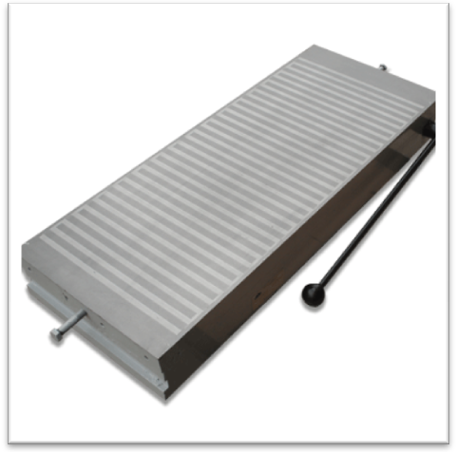

Magnetic Plates
Sizes, cm | From 100x250 up to 320x1000
Attractive force at full load, N/cm² | 60
Small-Pole Magnetic Plates
Sizes, cm | From 100x250 up to 320x1000
Attractive force at full load, N/cm² | 100
Magnetic Sine Swivel Plates
Working surface dimensions | From 125x400 up to 200x630
Attractive force at full load, N/cm² | 100

Electromagnetic plates are also designed for fixing ferromagnetic workpieces during their processing with surface grinders (with or without lubricating coolant). There are rectangular electromagnetic, small-pole electromagnetic and round small-pole electromagnetic plates of all sizes.
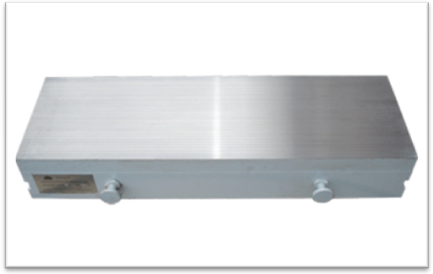
Rectangular Electromagnetic Plates
Sizes, cm | From 200x450 up to 630x2000
Attractive force at full load, N/cm² | 60
Round Small-Pole Electromagnetic Plates
Sizes, cm | From D=630 up to D=1000
Attractive force at full load, N/cm² | 80
Small-Pole Electromagnetic Plates
Sizes, cm | From 125x400 up to 630x2000
Attractive force at full load, N/cm² | 80

