CRM Field trip itinerary
Following the strong success of last year’s CRM field visit, we are pleased to announce that we are organising it again—this time with a focus on southern Kazakhstan. Building on growing momentum in EU–Kazakhstan co-operation, the visit will spotlight exciting new opportunities on the ground, connect participants with key local stakeholders, and explore projects and partnerships aligned with shared priorities. With major developments underway and a dynamic pipeline emerging, southern Kazakhstan offers a timely and compelling setting to deepen engagement and identify tangible avenues for collaboration.
Below you will find a map of Kazakhstan and the projects to visit for the field trip. Further details on each region and project as well as a tentative schedule follow on the next pages.
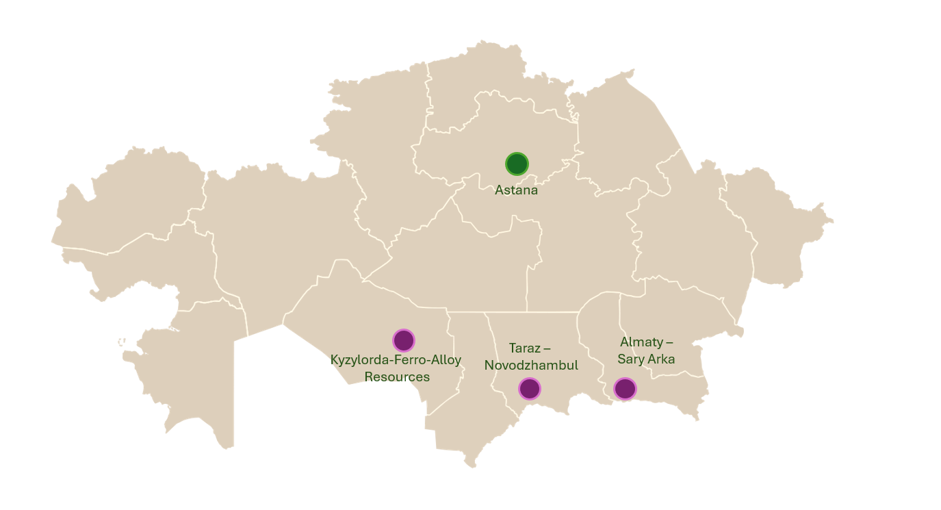
Project 1
Company | Ferro-Alloy Resources
Project | Balasausqandiq Project
Focus | Vanadium
Description | Ferro Alloy Resources is advancing a major vanadium project with growing strategic relevance for the energy storage sector, particularly as vanadium redox flow batteries (VRFBs) emerge as a scalable alternative to lithium-ion technologies for grid-level applications. Unlike lithium batteries, VRFBs offer long cycle life, high safety, and the ability to store large volumes of energy, making them well-suited for integrating renewable energy into power systems.  The project is based on a unique sedimentary orebody, which differs from conventional vanadium magnetite deposits by enabling processing without pre-concentration or roasting, significantly reducing energy intensity, emissions, and operating costs. This provides a potential competitive advantage in supplying low-carbon vanadium to global markets.  For the European Union, where the expansion of renewable energy capacity is driving demand for long-duration storage solutions, vanadium-based systems are gaining traction as part of a diversified battery ecosystem. At the same time, Europe remains highly dependent on external suppliers of vanadium, creating a clear need to diversify and secure supply chains.  In this context, Ferro Alloy Resources offers concrete opportunities for EU investors and industrial partners to engage in the development of a reliable, scalable and more sustainable source of vanadium, supporting both industrial resilience and the EU’s broader energy transition objectives.  More information: https://ferro-alloy.com

Project 2
Company | Sary Arka Mining
Project | Almaty Facility
Focus | Nickel, Cobalt
Description | Sary Arka has developed a cost-efficient, low-impact technology enabling the direct production of battery-grade nickel sulphate without intermediate processing steps - a critical innovation for the rapidly expanding lithium-ion battery industry. Nickel sulphate is a key input for cathode materials used in widely deployed battery chemistries such as NMC (nickel - manganese - cobalt), which underpin electric vehicles and stationary energy storage systems.  This technological capability positions Sary Arka within the strategically important midstream segment of the battery value chain, where value creation and supply risks are most concentrated. Today, global production of battery-grade chemicals-including nickel and cobalt sulphates - is heavily dominated by Asia, particularly China, creating structural dependencies for European industry.  Against this backdrop, Sary Arka’s approach offers a compelling pathway to diversify and localize supply chains for critical battery materials. By simplifying the processing route and reducing environmental footprint, the company’s technology could contribute to more resilient and transparent supply systems aligned with the EU’s Critical Raw Materials strategy and its target to expand domestic processing capacity.  The programme in Almaty will include a guided tour of Sary Arka’s laboratory facilities and pilot plant, where this proprietary process is being tested and demonstrated. The visit provides a timely opportunity to explore scalable, non-Chinese processing routes for battery-grade nickel and cobalt, strengthening cooperation on secure, sustainable and diversified supply chains between Kazakhstan and the European Union.  More information https://saryarkamining.kz/about.html

Project 3
Company | Novodzhambul Phosphorus Plant (NPP)
Project | Novodzhambul
Focus | Phosphor
Description | Kazakhstan is a key global supplier of phosphorus and phosphorus-based products, with strong export linkages to the European Union, the United States, and Asian markets. Building on this strategic position, the country is prioritizing the development of domestic value chains for battery materials, particularly LFP (lithium iron phosphate) batteries, which are gaining prominence due to their cost efficiency, safety, and supply chain resilience.  The Novodzhambul Phosphorus Plant (NDPP) - one of the major phosphorus producers globally-plays a central role in this ambition. The plant has well-established competencies in the production of phosphorus derivatives, including orthophosphoric acid, which is a critical precursor for LFP cathode materials. Leveraging its existing industrial base, infrastructure, and export capabilities, NPP is well-positioned to support the localization of precursor production and the broader battery manufacturing ecosystem in Kazakhstan.  In this context, Kazakhstan is actively seeking strategic partnerships with EU stakeholders to develop integrated production of LFP battery materials. This includes cooperation in technology transfer, establishment of precursor manufacturing (including iron phosphate), and potential downstream battery assembly. NDPP expresses readiness to participate in joint projects aimed at building a full-cycle battery value chain, from raw materials to finished products.  The initiative aligns with global efforts to diversify and secure critical mineral supply chains and offers EU partners a reliable, scalable, and geopolitically stable production base in Central Asia.  More information here: https://ndpp.kz .

Section II – Tentative itinerary
Please note that the programme is tight, as the field visit will cover significant distances across Kazakhstan. While every effort has been made to ensure a well-structured schedule, adjustments may be required due to travel times, logistical considerations, and local circumstances. Participants are therefore kindly requested to remain flexible, as the agenda may be subject to change at short notice.
Local transportation (bus and internal flights) as well as lunches will be provided by the EU. Participants need to cover (international) flights to Astana/ return from Almaty. Participants are also responsible for paying and booking their own accommodation. Hotel recommendations will be provided.

13 June (Saturday)
07.30 | Meeting Point: Hilton Astana
09.55-11.30 | Astana-Kyzylorda flight (FS-7315, FlyArystan)
12.00-14.00 | Transfer Kyzylorda to Shieli by bus
14.00-15.00 | Lunch
15.00-18.00 | Visit Ferro-Alloy Resources  https://www.ferro-alloy.com/  NDA must be signed prior to visiting the plant
18.00-20.00 | Transfer from the plant to the hotel in Kyzylorda
20.00 – 21.30 | Dinner
14 June (Sunday)
08.00 | Checkout from the hotel
10.25-12.00 | Kyzylorda-Almaty flight (FS-7116, FlyArystan)
12.30-13.30 | Transfer from airport to the pilot plant by bus  Lunch boxes provided
13.30 – 16.30 | Visit Sary Arka Mining company
16.30 – 18.00 | Transfer from the pilot plant to the hotel in Almaty
19.00-20.30 | Dinner
15 June (Monday)
03.00 | Checkout from the hotel in Almaty
05.30-06.30 | Almaty-Taraz flight (DV-757, Scat airlines)
07.00-08.00 | Transfer from airport to the plant by bus
08.00 – 12.00 | Visit NDPP (Novodzhambul Phosphorus Plant)
12.00-12.30 | Lunch
12.30-13.00 | Transfer to the airport in Taraz
14.40-15.40 | Taraz-Almaty flight (DV-758, Scat airlines)
16.30-17.30 | Transfer from airport in Almaty to the hotel/flight out

