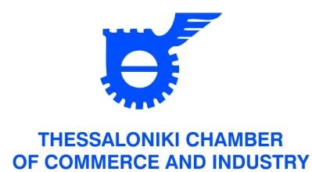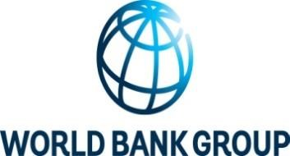

Black Sea Bridge

Business opportunities from IFI-financed projects and IFI financing (World Bank,
BSTDB, EBRD, MCC) Briefing-Networking

Thessaloniki - Greece: Tuesday June 19, 2018 at the Thessaloniki Chamber of Commerce and Industry

PARTICIPATION FORM

PARTICIPANT’S NAME:
COMPANY/ORGANISATION:
POSITION:
ADDRESS:
TELEPHONE: | FAX: | E-MAIL:
FIELD OF ACTIVITY:

I wish to participate to the Black Sea Bridge Business Forum: opportunities from IFIfinanced projects, in Thessaloniki on Tuesday June 19, 2018
I hereby authorize the organizers of the Black Sea Bridge Business Forum to use my personal and contact details (i.e. name and surname, organization/company name, e-mail, url, telephone and fax number) in order to facilitate the realization of business meetings (B2Bs) in the context of the Black Sea Bridge Business Forum (distribution of participants’ list etc)

Please return this form by e-mail or fax to the PSLO to the World Bank Group in Greece theo@ebeth.gr (fax number +302310 370136) by June 15, 2018. For more information please call +302310370120 or +302310370132.

