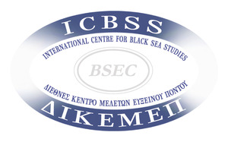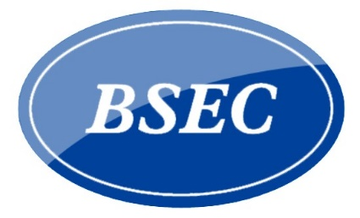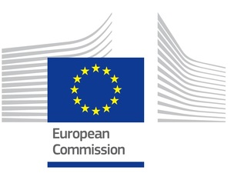
Online Workshop
How has the Covid-19 pandemic affected Blue Economy in the Black Sea region?
Potential response actions
Tuesday,16 June 2020
3pm EEST (2pm CEST)
Register Here

https://zoom.us/webinar/register/WN_06PBYdDGST6GI4AGEC7AJw

An online workshop to exchange views on the initial impact of the Covid-19 outbreak on key sectors of the Blue Economy in the Black Sea region, i.e. coastal and maritime tourism, maritime transport, fisheries and aquaculture. Particular attention will be paid on identifying potential response actions, also through the regional framework provided by the Common Maritime Agenda for the Black Sea.

Draft Agenda

Moderator: Mr. Stavros KALOGNOMOS, Executive Secretary, Balkan and Black Sea Commission (BBSC), Conference of Peripheral Maritime Regions (CPMR)
Opening Remarks: Regional dimension of the impact of Covid-19 and the importance to reinforce cooperation
Mr. Alexandru ENE, Director for the Western Balkans and Regional Cooperation, Ministry of Foreign Affairs of Romania (tbc)
Panelists:
The strategic role of the Common Maritime Agenda for the Black Sea
in supporting a coherent and coordinated response
Mr. Christos ECONOMOU, Head of Unit Sea-basin Strategies, Maritime Regional Cooperation and Maritime Security, DG MARE
Challenges and potential response actions:
Coastal and Maritime Tourism sector
Mr. Peter JANECH, Senior Officer, Department for Europe UN World Tourism Organisation (UNWTO)
Maritime Transport
Ms. Nadezhda BUHOVA, Director of European Coordination and International Relations Directorate and Coordinator of the Steering Group on the Common Maritime Agenda, Ministry of Transport, Information Technology and Communications of the Republic of Bulgaria
Fisheries and Aquaculture
Mr. Konstantin PETROV, GFCM Subregional Coordinator for the Black Sea
Q&A Session
***
Organised by the International Centre for Black Sea Studies (ICBSS), the Organisation of the Black Sea Economic Cooperation (BSEC) and the EU Commission's Directorate-General for Maritime Affairs and Fisheries (DG MARE)
in cooperation with the Bulgarian Coordination of the Common Maritime Agenda
