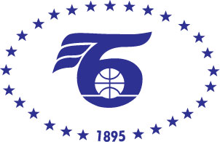
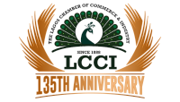

BUSINESS FORUM BULGARIA – NIGERIA

25 April 2023
BCCI, 9 Iskar Str., fl.1, Hall A

PROGRAMME

10.30 – 11.00 | REGISTRATION
11.00 – 11.30 | OFFICIAL OPENING  Mr. Tsvetan Simeonov  President of the Bulgarian Chamber of Commerce and Industry  MR. NIKOLA Stojanov  Minister of Economy and Industry of Bulgaria  MRS. Mariam Katagum  Minister of State for Industry, Trade and Investment of Nigeria  Dr. Michael Olawale-Cole  President of the Lagos Chamber of Commerce and Industry
11.30 – 11.40  11.40 – 11.50  11.50– 12.10 | Sighning of MOU between BCCI and LCCI  PRESENTATION of the investment climate and business opportunities in Bulgaria, InvestBulgaria Agency  PRESENTATION of the investment climate and business opportunities of Nigeria,
12.10 – 13.00 | B2B meetings

Working language: English

